**MySQL Activity**

1. Create Database & Table with field: 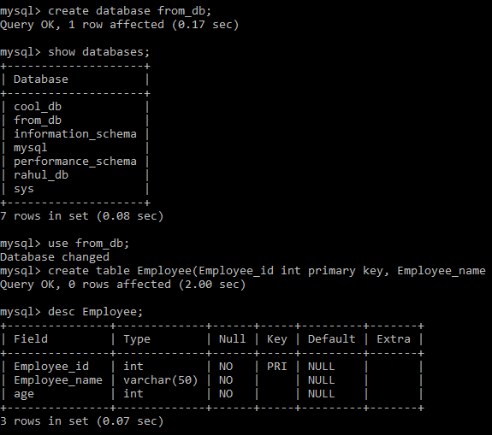
2. Alter table and modify Age with check constraint
3. Store the record and check the check constraint: 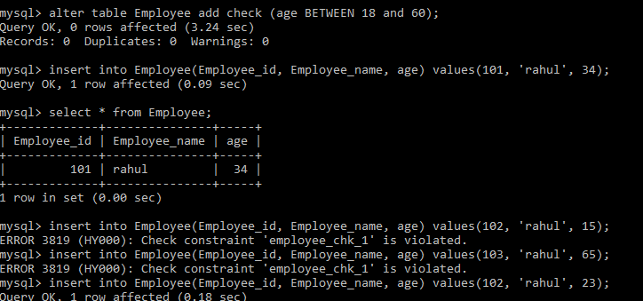
4. Store more records with same Email : 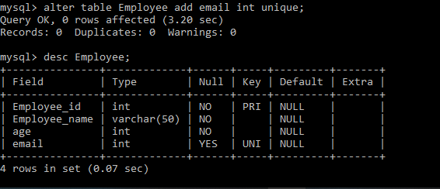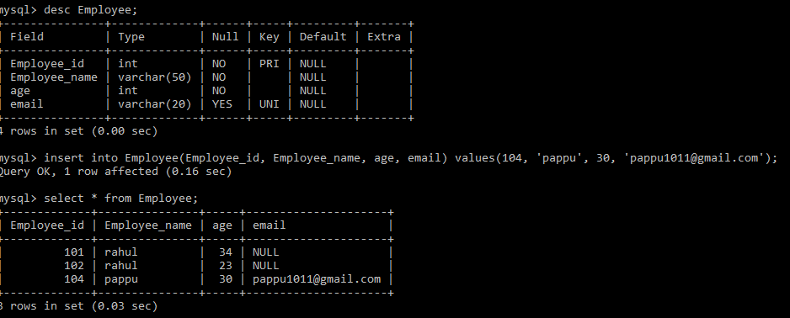
5. Alter table and add two new field PAN and AADHAAR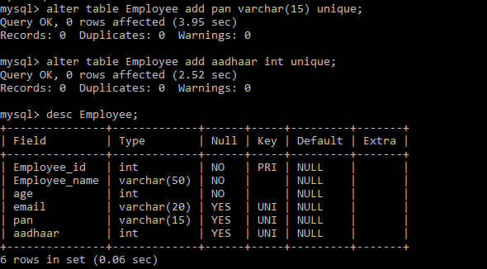
6. Check Unique constraint with passing duplicate value in same field and different record: 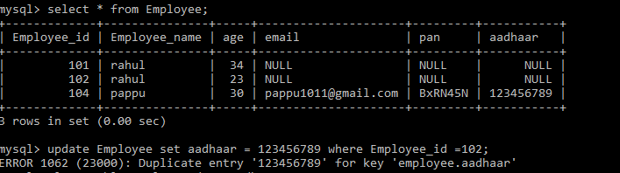
7. Alter the above employee table and remove the PAN and AADHAAR columns: 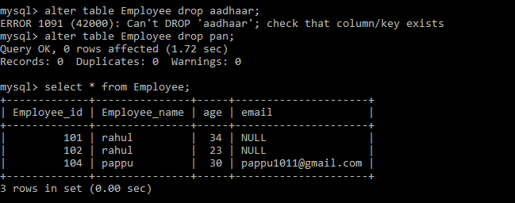
8. Using the DROP delete the employee table. 